Requirements Specification Document
STUDENT ESSENTIALS STORE
Group-6
Nandana Jayakumar: AM.SC.U4CSE25236
Gorrela Tulasi Lasya: AM.SC.U4CSE25218
Hansika Chawla: AM.SC.U4CSE25220
Lekshmi Nandana: AM.SC.U4CSE25230

1. Project Summary

1.1 Project Overview
The Student Essentials Store is a solution for students and faculty to easily browse and select their daily academic and personal needs. It allows users to view products such as stationery, gadgets, and study materials, and add them to a cart using a phone or any smart device. This web-based application provides a simple and interactive shopping experience, reducing the effort of searching for items and making the process quick and convenient.

1.2 Project Scope
The web application provides a user-friendly platform for students to browse and purchase essential academic and personal items. Users can access the website and explore a range of products such as stationery, gadgets, and study materials.
The system allows users to:
- View available products with details like name, price, and description
- Add or remove items from the cart
- Update the quantity of selected products
- View the total price of items in the cart before checkout.
- Sellers can add items that can be purchased by buyers.
- Sellers can view their profile with the recent items added.
- Buyers can view their history of purchase in their profile page.
- Both sellers and buyers can reset their password.
Product browsing can be organized based on:
- Category (stationery, gadgets, accessories)
- Price range
The website also includes a contact section where users can submit queries or feedback through a form with proper validation.

2.0 General Description

2.1 Product Functions Overview

Types of users/actors
- Buyers
- Sellers
Buyers features
- Register and login to the website.
- Update their profile.
- Add ,update and remove products from the cart.
- Checkout and buy products in cart.
- View previously bought products.
- Able to Logout.
- Able to reset password.
Sellers features
1. Able to Login and Register into the website.
2. Create, update and edit products.
3.Edit profile and information.
4. Update stock of products.
5. Able to Logout.
6. Able to reset password

  - User interface Design
DEFAULT PAGE :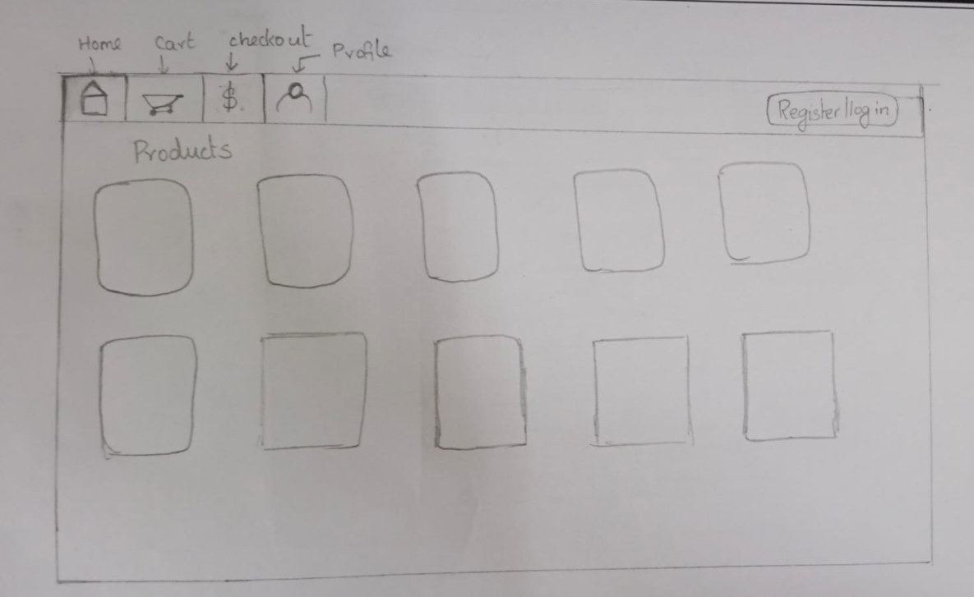
REGISTER PAGE:

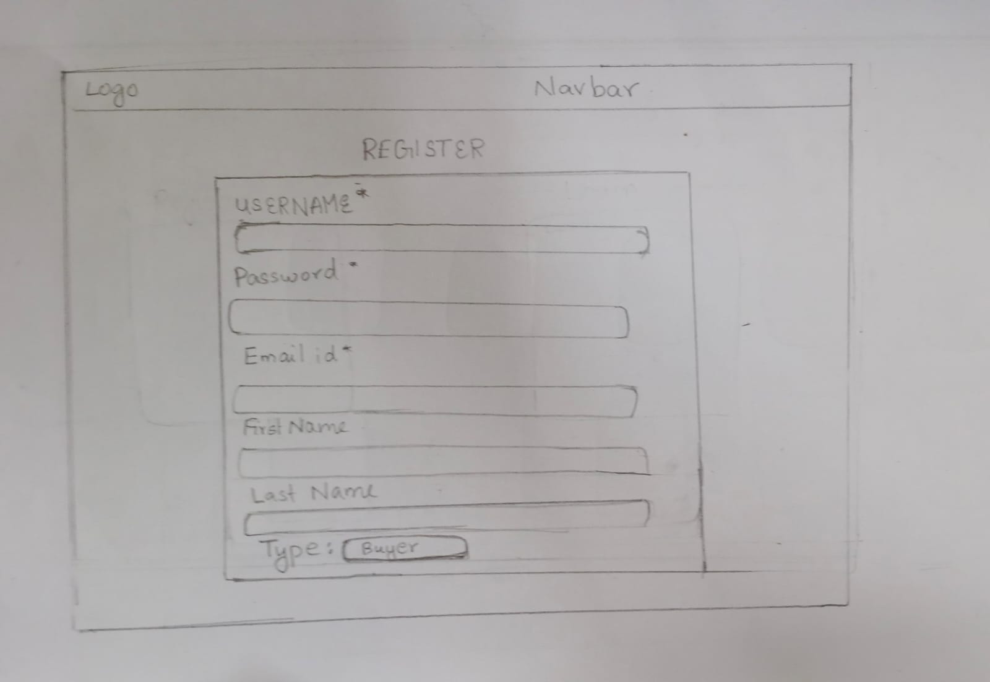

LOGIN PAGE:
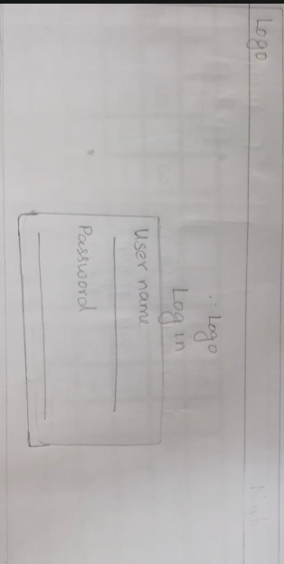

USER DASHBOARD :
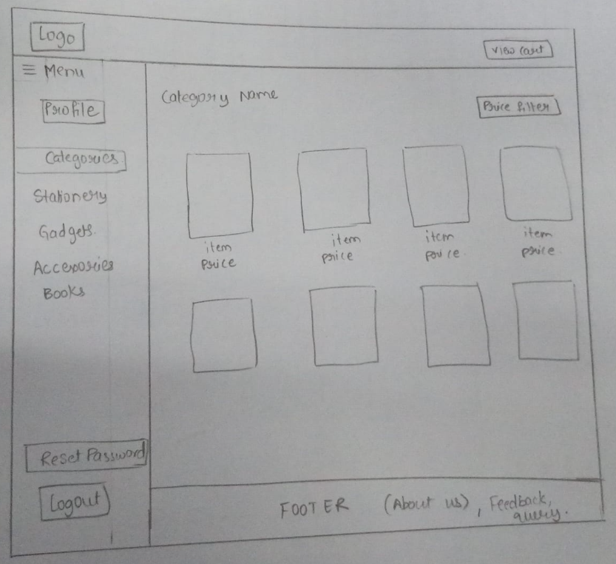

USER PROFILE:
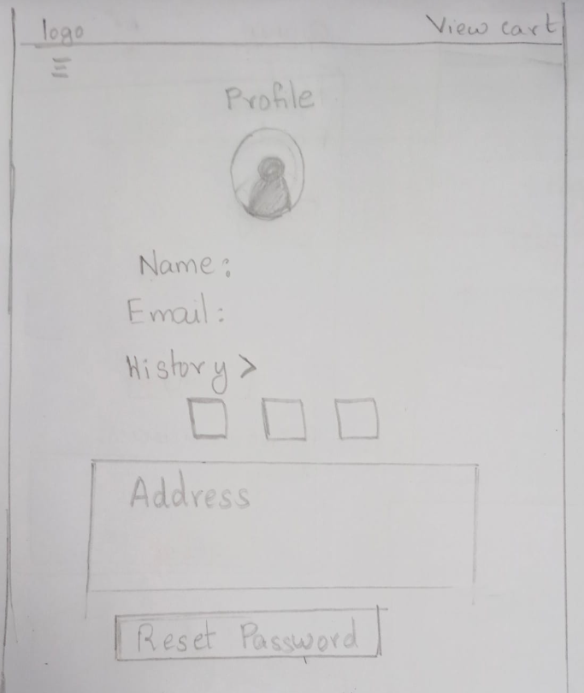

VIEW CART:
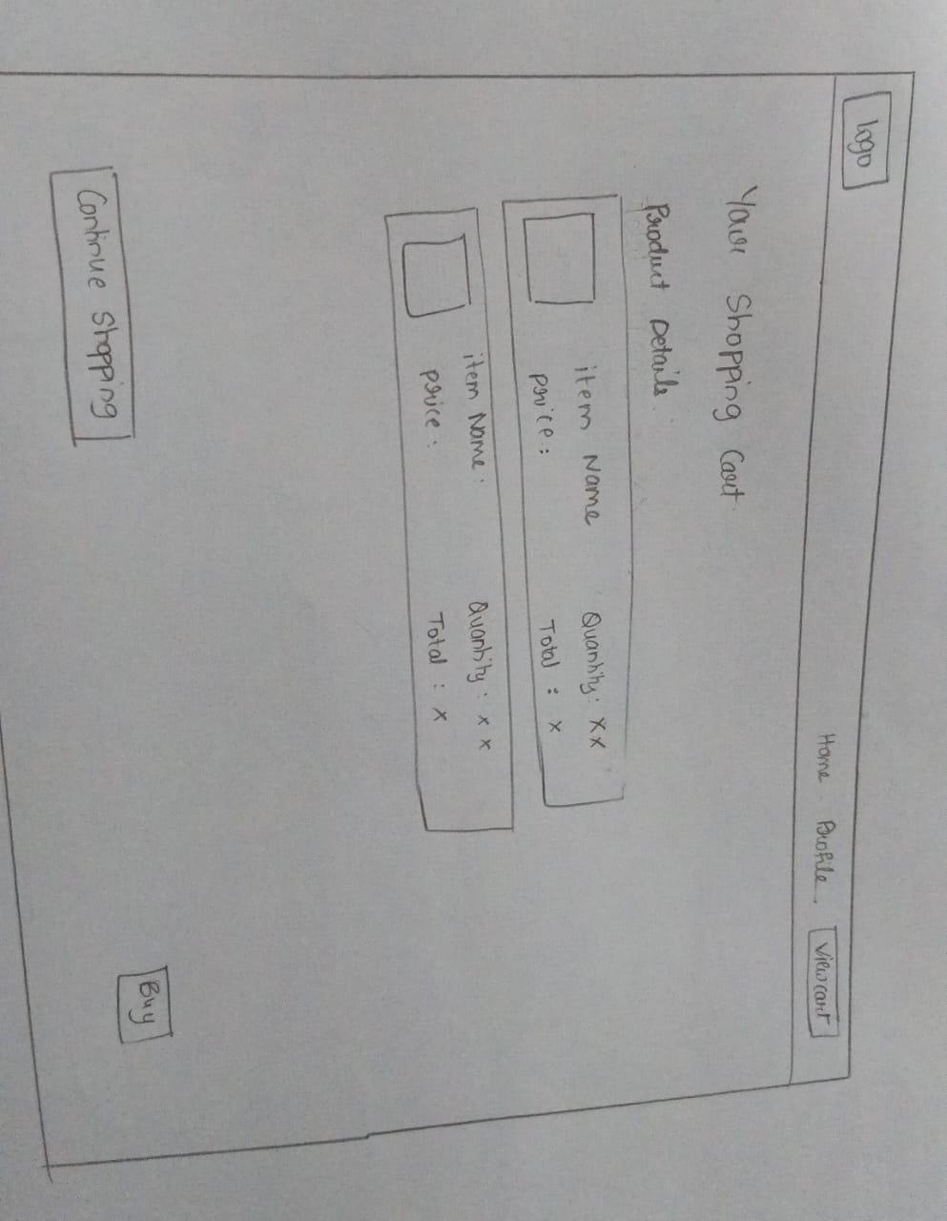

BILLING:
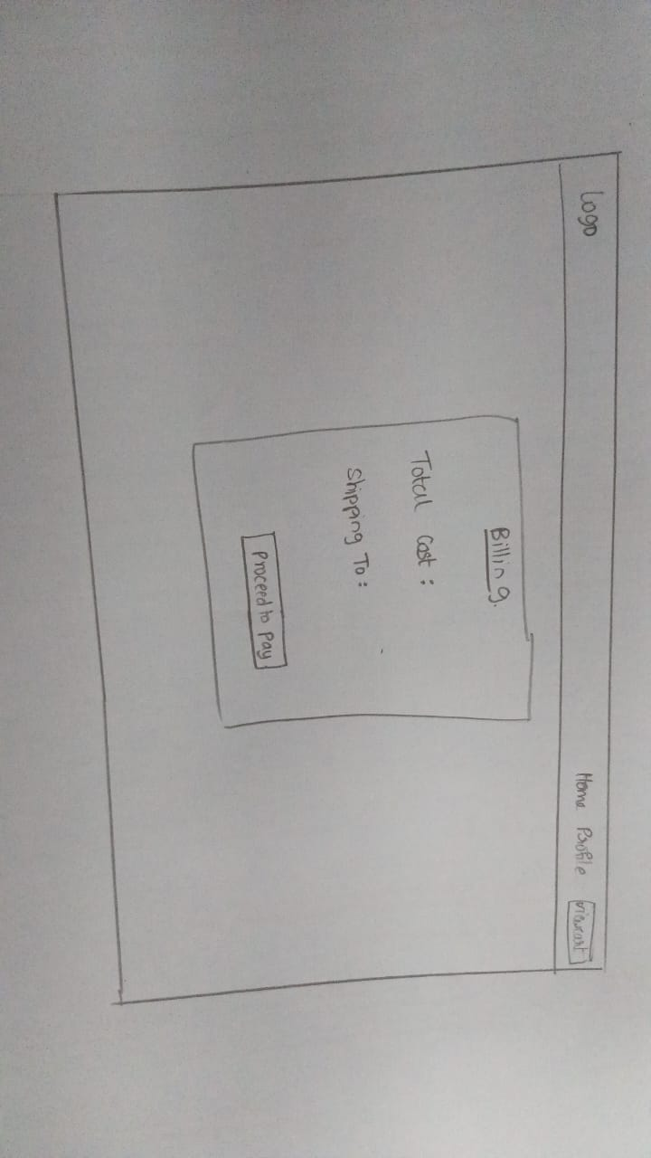
FEEDBACK:
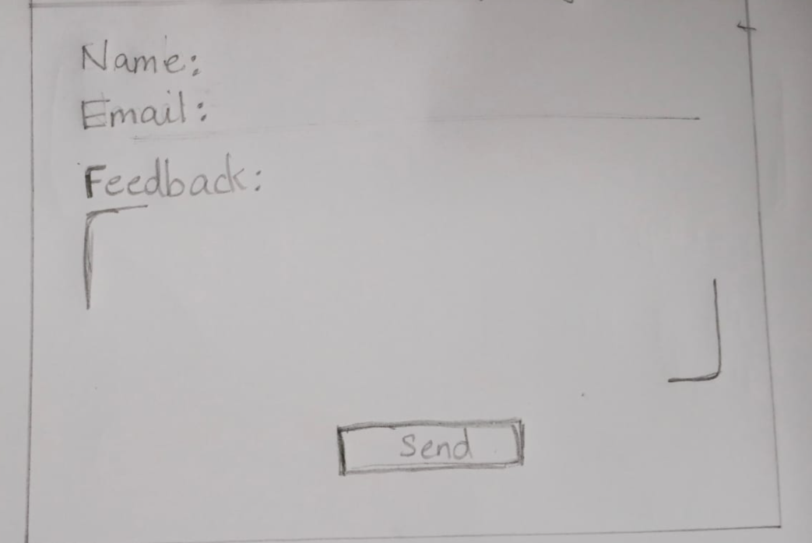

QUERY:
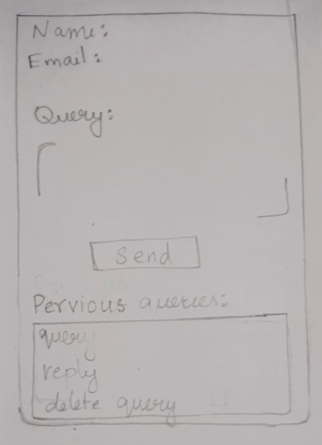

SELLER PROFILE:
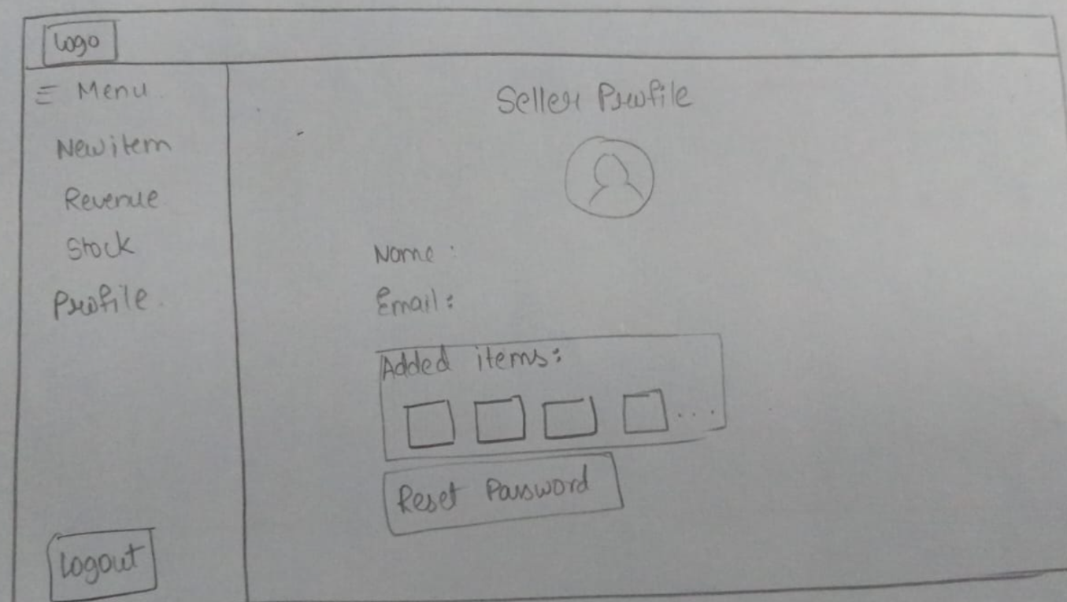

SELLER ADD ITEM:
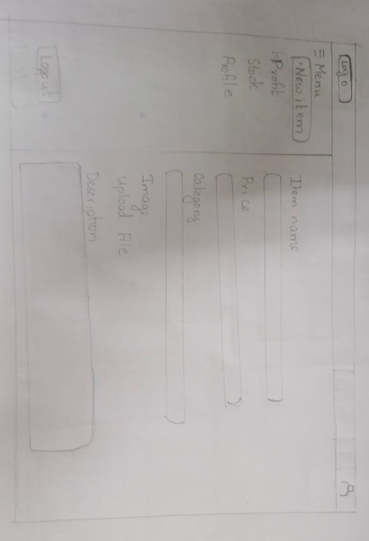

STOCK PAGE:
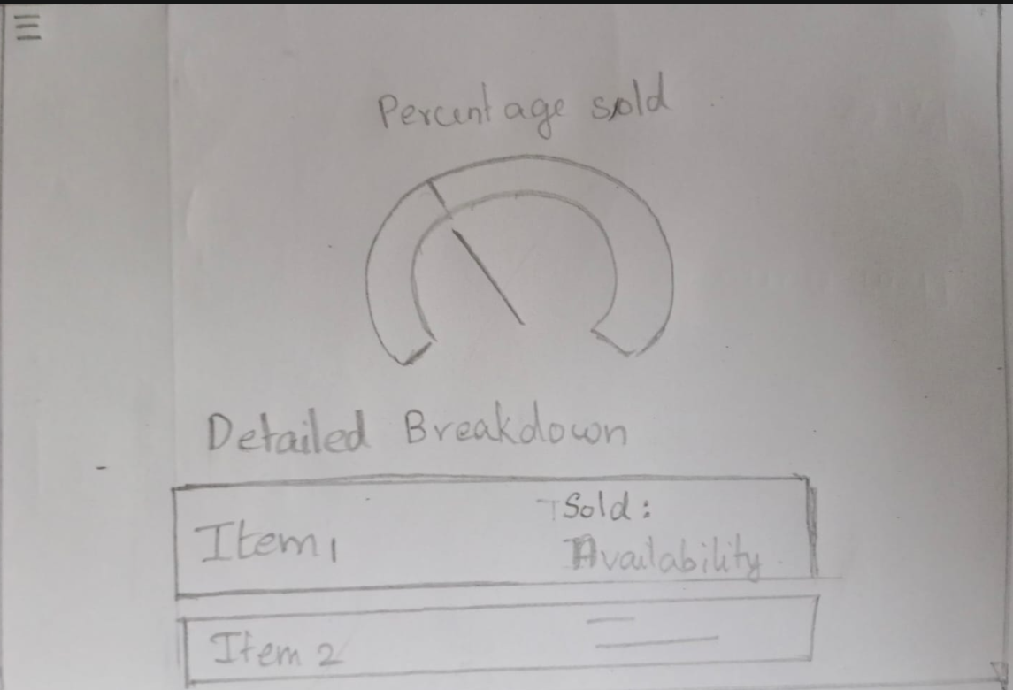

PROFIT PAGE:
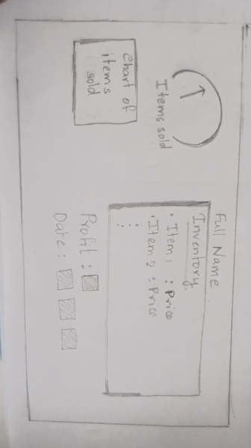

RESET PASSWORD:
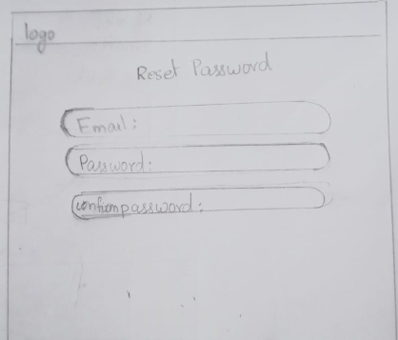

2.3 Link to the developer’s website
Nandana Jayakumar: https://nand-j1.github.io/UID-PROJECT-PHASE-1/
Gorrela Tulasi Lasya: https://tulasilasya.github.io/TulasiLasyaPortfolio.github.io/
Hansika Chawla: https://hansi-111.github.io/User-Interface-Design-Project/
Lekshmi Nandana: https://l-xmi07.github.io/Portfolio/

